Test Login

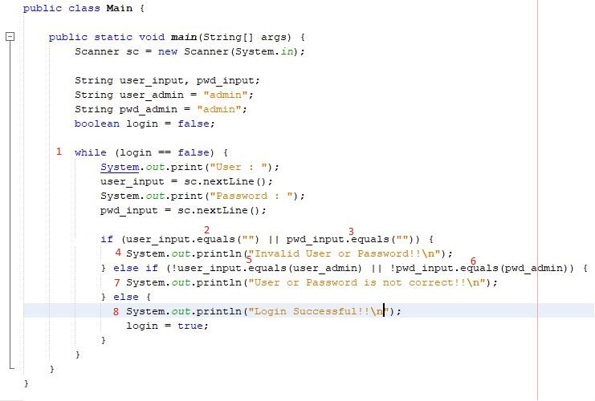

Xác định các nút

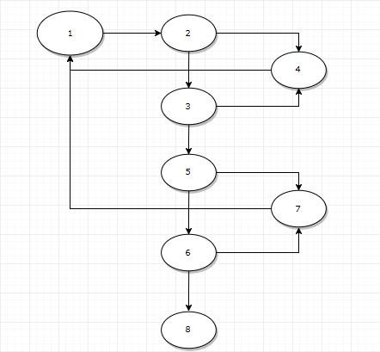

Đồ thị diễn tiến chương trình

|  |  |
| --- | --- |
| 1 | 1,2,4,1 |
| 2 | 1,2,3,4,1 |
| 3 | 1,2,3,5,7,1 |
| 4 | 1,2,3,5,6,7,1 |
| 5 | 1,2,3,5,6,8 |

Các đường kiểm thử

|  |  |  |
| --- | --- | --- |
| Đường kiểm thử | Input | Kết quả |
| 1 | User = none, password = a | Lỗi : Chưa nhập user or password |
| 2 | User = a, password = none | Lỗi : Chưa nhập user or password |
| 3 | User = a, password = admin | Lỗi : Sai user or password |
| 4 | User = admin, password = a | Lỗi : Sai user or password |
| 5 | User = admin, password = admin | Login Successful |

Test case cho từng trường hợp